Student Enrollment & Course Management System (SECMS)

User Story:
As a student, I want a simple system through which I can view available courses, provide my academic details, and submit enrollment requests without depending on manual procedures. As an enrollment staff member, I want to maintain student and course information in one place so that registration activities can be handled easily. The system should also help administrators monitor enrollments and instructors manage the students assigned to their courses.

1. INTRODUCTION

1.1 Project Overview :

The Student Enrollment & Course Management System is developed to organize the different activities involved in student registration and course enrollment. In many institutions, student information, course details, and enrollment records may be maintained separately, which can make it difficult to find updated information quickly.
The proposed system brings these activities together in a single Salesforce application. It provides a common platform for maintaining student profiles, course information, instructor details, and enrollment records. Users can work with the information according to their assigned responsibilities.
The system also uses Salesforce features to reduce repeated manual work. Important enrollment activities can be handled through automated flows, validation rules, approval processes, reports, and dashboards. This makes the overall process more organized and easier to monitor.

1.2 Purpose :

The main purpose of the project is to provide an organized digital method for handling student enrollment and course-related activities. The system is intended to:

Maintain student information in a structured manner.

Store course and instructor details centrally.

Make enrollment processing easier.

Reduce errors caused by repeated manual entry.

Provide useful reports for academic management.

Give authorized users access to relevant information.

2. IDEATION PHASE
2.1 Problem Statement (Customer Problem Statement Template)



2.2 Empathy Map Canvas
User Personal: Student
Think & Feel: Wants the enrollment process to be clear and simple.
Hear: Information from faculty members, classmates, and enrollment staff.
See: Course details, available options, registration forms, and enrollment status.
Say & Do: Searches for suitable courses and checks the status of submitted requests.
Pain: Unclear course information and delays in knowing the enrollment status.
Gain: Easy course selection, simple registration, and quick status updates.
User Persona: Enrollment Officer
Think & Feel: Wants to complete student requests without unnecessary delay.
Hear: Questions and requests from students and faculty.
See: Student records, course details, and pending enrollment requests.
Say & Do: Verifies information and updates enrollment records.
Pain: Repeated data entry and checking multiple records.


2.3 Brainstorming & Idea Prioritization
Step 1 – Brainstormed Ideas
The following ideas were considered during the initial discussion:
Online student registration system
Course selection and enrollment portal
Centralized student database
Salesforce-based management system
Automated enrollment tracking system
Step 2 – Grouping
Grouping
The ideas were divided into three main categories:
Manual Approach
Paper-based registration
Spreadsheet maintenance
Manual status updates
Partially Digital Approach
Online forms
Spreadsheet-based tracking
Separate communication channels
Integrated Approach
Centralized Salesforce application
Automated workflows
Reports and dashboards
Step3–Prioritization
The Salesforce-based approach was considered for implementation because it can bring student, course, instructor, and enrollment information into one application. It also provides built-in tools for automation, security, reporting, and workflow management.



3.REQUIREMENT ANALYSIS PHASE

3.1 Customer Journey Map
The customer journey for the proposed system includes the following stages:
Stage 1 – Student Registration
The student details are entered into the system and a student record is created.
Stage 2 – Course Discovery
The student checks the available courses and selects a course based on their requirement.
Stage 3 – Enrollment Submission
The selected course is submitted as an enrollment request.
Stage 4 – Information Verification
The enrollment information is checked before the request is processed further.
Stage 5 – Approval
The request is sent to the responsible person for approval.
Stage 6 – Instructor Assignment
After the enrollment is accepted, the appropriate instructor can be associated with the enrollment.
Stage 7 – Confirmation and Tracking
The enrollment status is updated and the record can be monitored through the system.
Stage 8 – Reporting
The stored information can be used to prepare reports related to students, courses, and enrollments.


3.2 Solution Requirements
Functional Requirements

FR No | Epic | Description
FR-1 | Student Management | Create and maintain student profiles.
FR-2 | Course Management | Store and update course information.
FR-3 | Enrollment Management | Record and process student enrollment requests.
FR-4 | Instructor Management | Maintain instructor information and assignments.
FR-5 | Approval Management | Process enrollment requests through an approval workflow.
FR-6 | Reporting | Generate reports based on stored academic information.

Non-Functional Requirements
NFR-1: Usability
The application should be simple enough for students and staff to understand without extensive training. Important options should be clearly available so that users can complete common activities without confusion.
Examples:
Clear navigation between objects.
Simple record creation forms.
Easy access to enrollment information.
NFR-2: Security
Student and academic information should be protected from unauthorized access. Users should receive access according to their responsibilities.
Examples:
Administrator has wider system access.
Enrollment staff can manage enrollment-related records.
Instructors can access information relevant to their work.
NFR-3: Reliability
The system should provide consistent results when records are created or updated. Automation and validation should work correctly during normal operations.
Examples:
Required information should not be missed.
Enrollment status should update correctly.
Records should remain consistent after changes.

3.3 Data Flow Diagram
The system follows a simple flow for handling enrollment information.
The user enters the required student or enrollment information.
The system checks whether the entered information is valid.
Valid information is stored in the corresponding Salesforce object.
Enrollment requests are moved through the required processing stage.
The responsible user reviews the request.
The enrollment status is updated based on the action taken.
Reports and dashboards use the stored records for monitoring.
The main data flow connects Student → Course → Enrollment → Instructor → Approval → Reports.
This flow helps maintain a clear connection between the different parts of the enrollment process.

3.4 Technology Stack
Layer | Technology
User Interface | Salesforce Lightning
Application Logic | Salesforce Flow
Data Storage | Salesforce Objects
Automation | Validation Rules and Approval Process
Reporting | Salesforce Reports
Visualization | Salesforce Dashboards

4. PROJECT DESIGN PHASE

4.1 Problem–Solution Fit
The proposed system is designed around the actual activities involved in student enrollment. Students require an easier way to submit enrollment requests, while staff members need organized records to process those requests.
The system connects these requirements through Salesforce objects and automation features. Student information, course information, enrollment records, and instructor details can be maintained in a connected environment.
Validation rules help check entered information, while flows can perform repeated tasks automatically. Approval processes can be used when an enrollment requires confirmation from an authorized person.
The solution therefore provides a structured approach for managing the enrollment process instead of depending completely on manual record handling.


4.2 Proposed Solution
Functional Requirements

Parameter | Description
Problem | Manual enrollment handling
Solution | Salesforce-based SECMS
Novelty | End-to-end automation
Social Impact | Improved student experience
Revenue Model | Institutional deployment
Scalability | Multi-department support

4.3 Solution Architecture
The proposed architecture contains multiple connected components.
User Layer:
Students and staff interact with the Salesforce application through the available interface.
Data Layer:
Student, Course, Instructor, and Enrollment objects store the required information.
Automation Layer:
Flows and validation rules perform automated actions and check the data entered by users.
Approval Layer:
Enrollment requests can be sent to the responsible authority for confirmation.
Reporting Layer:
Reports and dashboards present the stored information in a more understandable format.


5. PROJECT PLANNING & SCHEDULING

5.1 Project Planning
- Agile methodology
- Epics → Stories → Story Points
- Sprint-based execution
- Velocity calculation used for estimation
Product Backlog, Sprint Schedule, and Estimation (4 Marks)
Use the below template to create product backlog and sprint schedule
Sprint | Functional Requirement (Epic) | User Story Number | User Story / Task | Story Points | Priority | Team Members
Sprint-1 | Developer Setup | USN-1 | As a system administrator, I want to create a Salesforce developer account so that I can configure and deploy the Student Enrollment system.. | 1 | High | Member1
Sprint-1 | Data Modeling | USN-2 | As an admin, I want to create custom objects for Student, Course, Enrollment, and Instructor so that academic data can be stored and managed efficiently. | 3 | High | Member2
Sprint-2 | Data Modeling | USN-3 | As a user, I want dedicated tabs for each object so that I can easily navigate between students, courses, enrollments, and instructors. | 3 | High | Member3
Sprint-2 | Data Modeling | USN-4 | As an admin, I want to create relevant fields such as student details, course information, and enrollment status so that complete records can be captured accurately. | 5 | High | Member4
Sprint-2 | Data Modeling | USN-5 | As an enrollment officer, I want a centralized Lightning App so that I can access all academic operations from one interface. | 3 | High | Member4
Sprint-2 | Data Modeling | USN-6 | As an admin, I want to define relationships between students, courses, and enrollments so that the system can logically link and track academic activities. | 5 | Medium | Member1
Sprint-2 | Data Modeling | USN-7 | As a user, I want customized page layouts so that only relevant information is displayed, improving clarity and ease of data entry. | 5 | High | Member2
Sprint-3 | Automation | USN-8 | As a system, I want to validate input data such as mandatory fields and enrollment limits so that incorrect or incomplete records are prevented. | 3 | High | Member4
Sprint-3 | Automation | USN-9 | As a system, I want automated flows to handle enrollment processing and notifications so that manual effort is reduced and processes become faster. | 3 | High | Member4
Sprint-3 | Automation | USN-10 | As an administrator, I want an approval process for enrollment requests so that registrations are verified before confirmation. | 5 | High | Member1
Sprint-4 | Security | USN-11 | As an admin, I want to configure role-based security so that users can only access data relevant to their responsibilities. | 5 | High | Member2
Sprint-5 | Reports | USN-12 | As a manager, I want reports on student enrollments, course registrations, and instructor assignments so that I can monitor academic operations. | 4 | High | Member3
Sprint-6 | Dashboards | USN-13 | As a manager, I want visual dashboards showing enrollment statistics and trends so that I can quickly analyze system performance. | 4 | Medium | Member4

Project Tracker, Velocity & Burndown Chart: (4 Marks)
Sprint | Total Story Points | Duration | Sprint Start Date | Sprint End Date (Planned) | Story Points Completed (as on Planned End Date) | Sprint Release Date (Actual)
Sprint-1 | 20 | 6 Days | 24 Oct 2022 | 29 Oct 2022 | 20 | 29 Oct 2022
Sprint-2 | 20 | 6 Days | 31 Oct 2022 | 05 Nov 2022
Sprint-3 | 20 | 6 Days | 07 Nov 2022 | 12 Nov 2022
Sprint-4 | 20 | 6 Days | 14 Nov 2022 | 19 Nov 2022

6. Project Development Phase:

Project Flow:

Milestone 1: Salesforce Developer Account Creation
Milestone 2: Custom Object Creation (Student, Course, Enrollment, Instructor)
Milestone 3: Tabs Creation
Milestone 4: Lightning App Creation
Milestone 5: Fields Creation
Milestone 6: Create Relationships
Milestone 7: Page Layout Customization
Milestone 8: Validation Rules
Milestone 9: Flows (Automation)
Milestone 10: Approval Process
Milestone 11: Reports
Milestone 12: Dashboards
Milestone 13: Security Setup
Milestone 14: Conclusion

What you'll learn
- Real-time Salesforce project implementation
- Designing custom objects and relationships
- Creating page layouts & record types
- Writing validation rules
- Building automation with flows
- Creating approval workflows
- Developing reports & dashboards
- Setting up security with profiles, permission sets, and sharing
- End-to-end application testing

Milestone 1-Salesforce :
Introduction:

Are you new to Salesforce? Not sure exactly what it is, or how to use it? Don’t know where you should start on your learning journey? If you’ve answered yes to any of these questions, then you’re in the right place. This module is for you.
Welcome to Salesforce! Salesforce is game-changing technology, with a host of productivity-boosting features, that will help you sell smarter and faster. As you work toward your badge for this module, we’ll take you through these features and answer the question, “What is Salesforce, anyway?”.

What Is Salesforce?

Salesforce is your customer success platform, designed to help you sell, service, market, analyze, and connect with your customers.
Salesforce has everything you need to run your business from anywhere. Using standard products and features, you can manage relationships with prospects and customers, collaborate and engage with employees and partners, and store your data securely in the cloud. So what does that really mean? Well, before Salesforce, your contacts, emails, follow-up tasks, and prospective deals might have been organized something like this:
https://youtu.be/r9EX3lGde5k

Activity 1: Creating Developer Account:
Creating a developer org in salesforce.
Go to https://developer.salesforce.com/signup
On the sign up form, enter the following details :
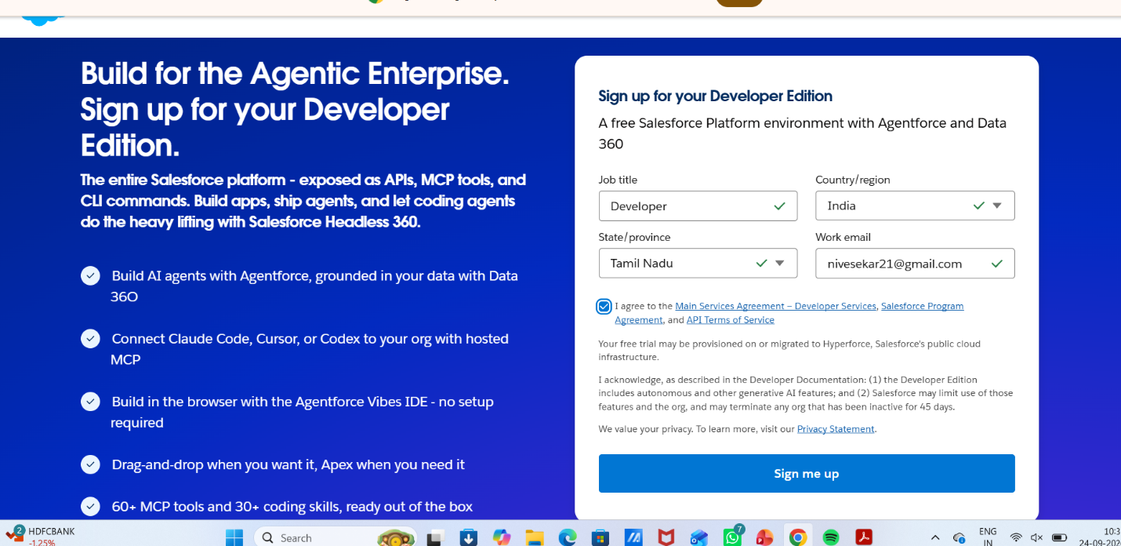
First name & Last name
Email
Role : Developer
Company : SRI AKILANDESWARI WOMEN’S COLLEGE
County : India
Postal Code : pin code
Username : should be a combination of your name and company
This need not be an actual email id, you can give anything in the format : username@organization.com
Click on sign me up after filling these.

Activity 2: Account Activation:

1. Go to the inbox of the email that you used while signing up. Click on the verify account to activate your account. The email may take 5-10mins.



2. Click on Verify Account
3. Give a password and answer a security question and click on change password.
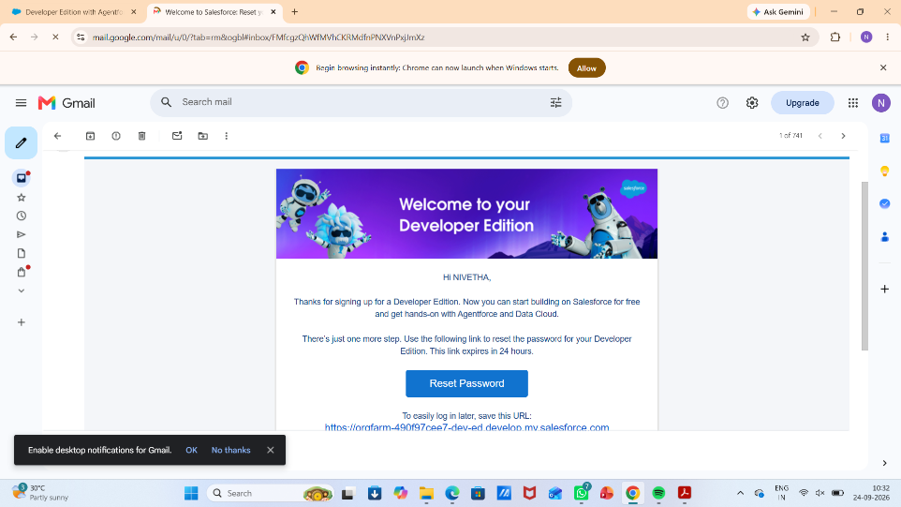

4. Then you will redirect to your salesforce setup page.
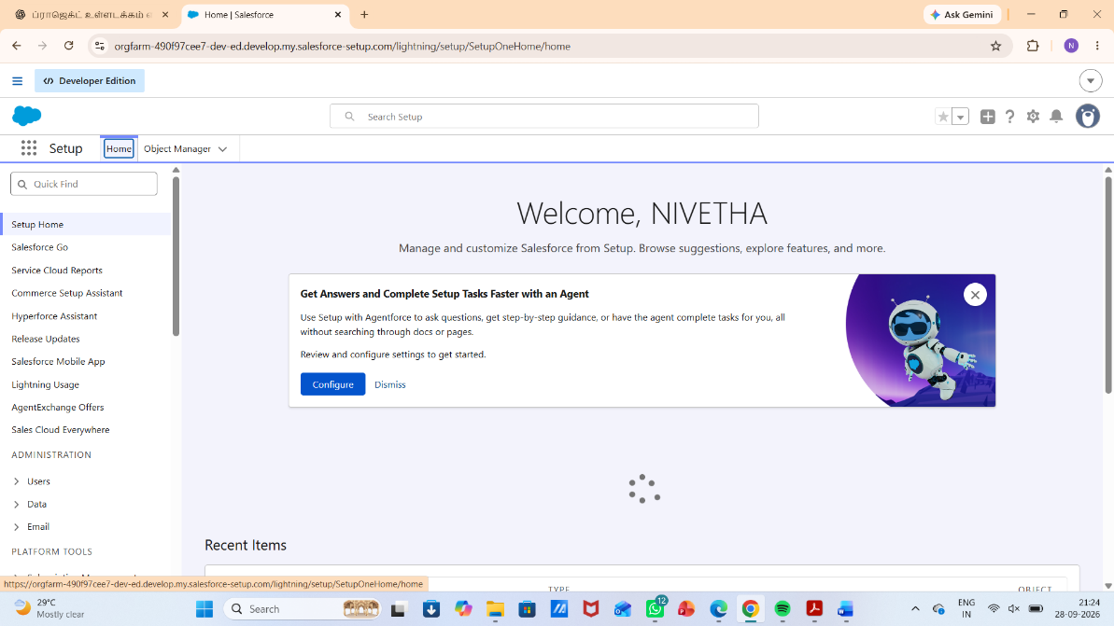

Milestone 2 – Objects:

Activity 1: Creating Student Object:
The purpose of creating the Student custom object is to store and manage information about students such as their personal details, contact information, and enrollment status.

To create the Student object:

Go to the Setup page.

Click on Object Manager.

Click on Create → Custom Object.

Enter the details as below:
- Label: Student
- Plural Label: Students
- Object Name: Student
- Record Name: Student Name
- Data Type: Text
- Under Optional Features, select:
- Allow Reports
- Allow Activities (optional but recommended)
- Track Field History (optional, if you want)
- Under Search Status, select:
- Allow Search
- Click Save.

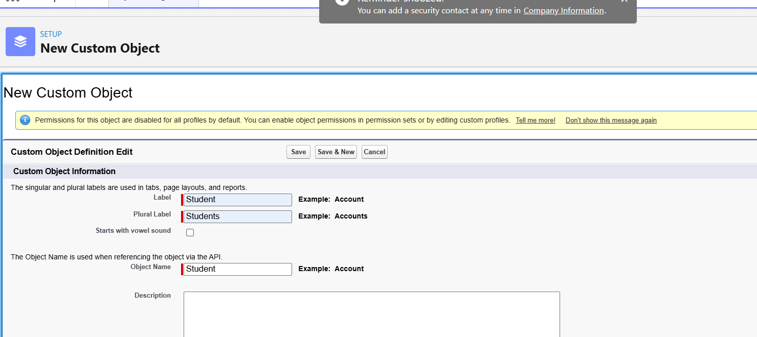

In the same way Create Courses, Instructors, and Enrolments objects

Milestone 3 - Fields:

Table 1: Student Object Fields:

Field Label | Data Type
Student Name | Text (Standard)
Email | Email
Phone | Phone
Date of Birth | Date
Student Status | Picklist
Address | Text Area

Table 2: Course Object Fields:

Field Label | Data Type
Course Name | Text (Standard)
Category | Picklist
Duration | Number/Text
Course Fee | Currency
Description | Text Area

Table 3: Instructor Object Fields:

Field Label | Data Type
Instructor Name | Text (Standard)
Instructor Code | Text
Expertise | Picklist
Phone | Phone
Email | Email

Table 4: Enrollment Object Fields:

Field Label | Data Type
Student | Lookup (Student)
Course | Lookup (Course)
Instructor | Lookup (Instructor)
Enrollment Date | Date
Enrollment Status | Picklist
Fees Paid | Checkbox
Total Amount | Currency
Comments | Text Area

Milestone 4 – Create Relationships:

Activity 1: Create Lookup from Enrollment to Student:
- Go to Setup → click Object Manager.
- Type Enrollment in Quick Find → click Enrollment__c object.
- Click Fields & Relationships → click New.
- Select Lookup Relationship → click Next.
- For Related To, select Student__c → click Next.
- Enter Field Label: Student (API Name: Student__c).
- Click Next through Field-Level Security and Layout options (ensure it’s visible and added to layout).
- Click Save.
- 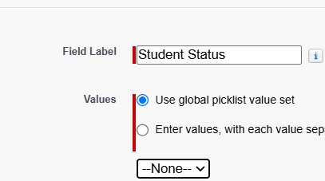

Activity 2: Create Lookup from Enrollment to Course
Purpose:
To link each Enrollment to a Course.

Steps:
- Go to Setup → Object Manager → Enrollment__c.
- Click Fields & Relationships → New.
- Select Lookup Relationship → Next.
- Related To: select Course__c → click Next.
- Field Label: Course (API Name: Course__c).
- Click Next (set visibility and layout) → Save.
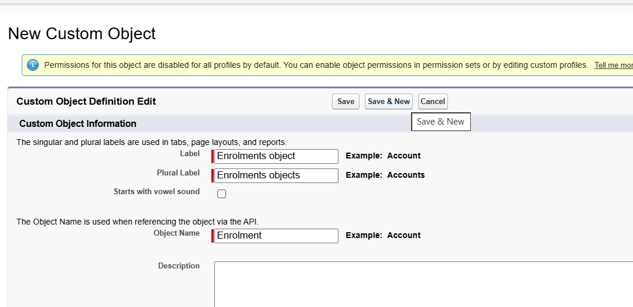

Activity 3: Create Lookup from Enrollment to Instructor:
Purpose:
To store which Instructor is assigned to a particular Enrollment.

Steps:
- Go to Setup → Object Manager → Enrollment__c.
- Click Fields & Relationships → New.
- Choose Lookup Relationship → Next.
- Related To: select Instructor__c → Next.
- Field Label: Instructor (API Name: Instructor__c).
- Complete Field-Level Security and Page Layout options → Save

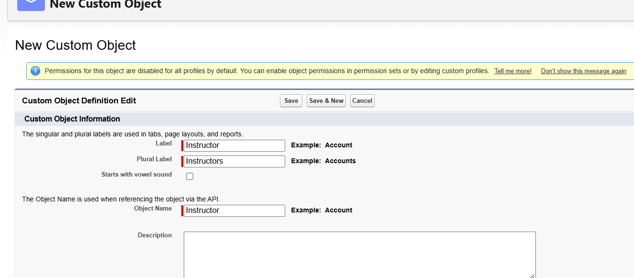

Milestone 5 – Validation Rules:
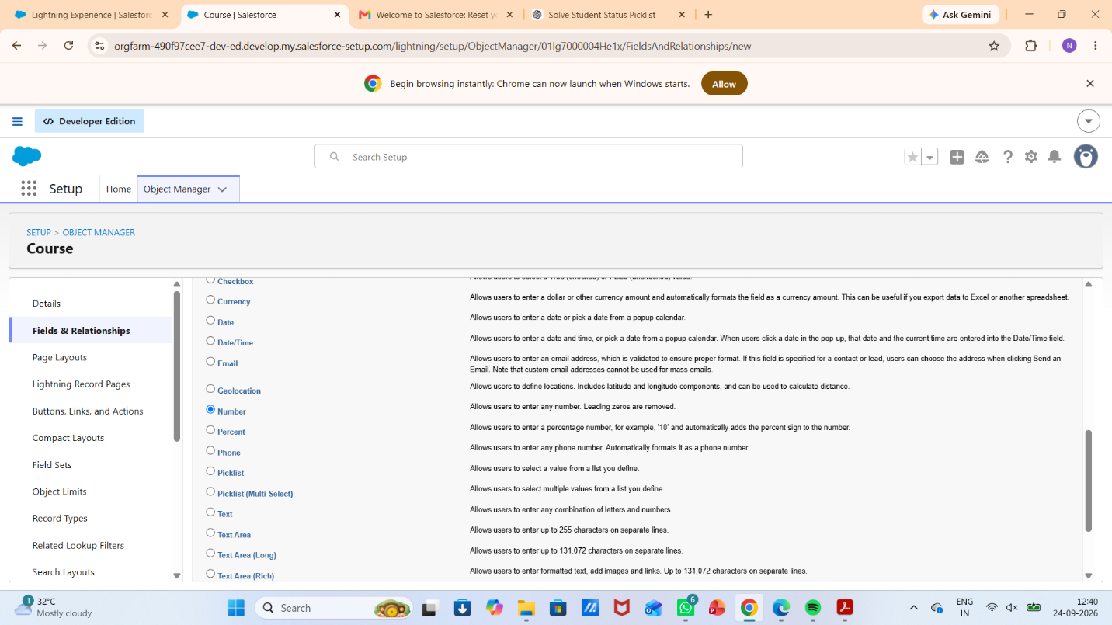

Activity 1: Student Email Domain Validation
Purpose:
To ensure students use only allowed institutional email addresses.

Steps:

Go to Setup → Object Manager → Student__c.
Click Validation Rules → New.
Rule Name: Student_Email_Domain_Validation.
Error Condition Formula: (example for @student.edu)
- NOT(CONTAINS(Email__c, "@student.edu"))

Error Message: Email must be a valid student institutional email.
Error Location: Field → Email__c.
Click Save.

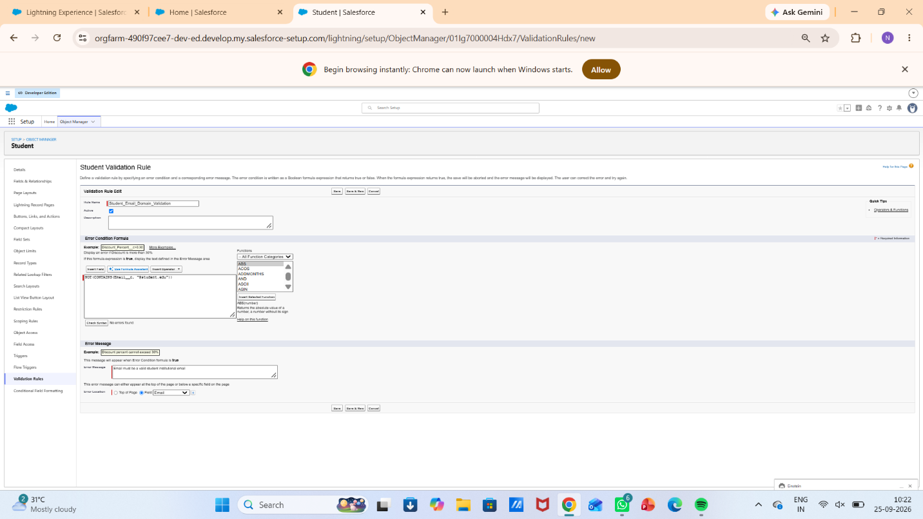

Activity 2: Fees Must Be Paid Before Approval

Purpose:
Prevent Enrollment from being approved until fees are paid.

Steps:

- Go to Setup → Object Manager → Enrollment__c.
- Click Validation Rules → New.
- Rule Name: Fees_Must_Be_Paid_Before_Approval.
- Error Condition Formula:
AND(
ISPICKVAL(Enrollment_Status__c, "Approved"),
Fees_Paid__c = FALSE
)
5.Error Message: Fees must be paid before approving an enrollment.
6.Error Location: Top of Page (or field as needed).
Click Save.

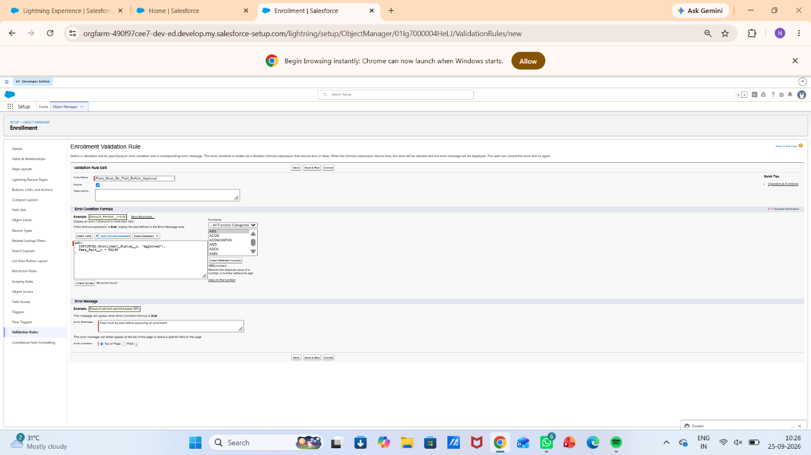

Milestone 6 – Approval Process

Activity 1: Create Approval Process for Enrollment Requests

Purpose:
Route Enrollment requests to the Training Manager for approval or rejection.

Steps:

- Go to Setup → Approval Processes → select Enrollment__c.
- Click Create New Approval Process → Use Standard Setup.
- Process Name: Approval_Enrollment_Request.
- Entry Criteria: Enrollment_Status__c = "Requested".
- Save and configure steps.
- 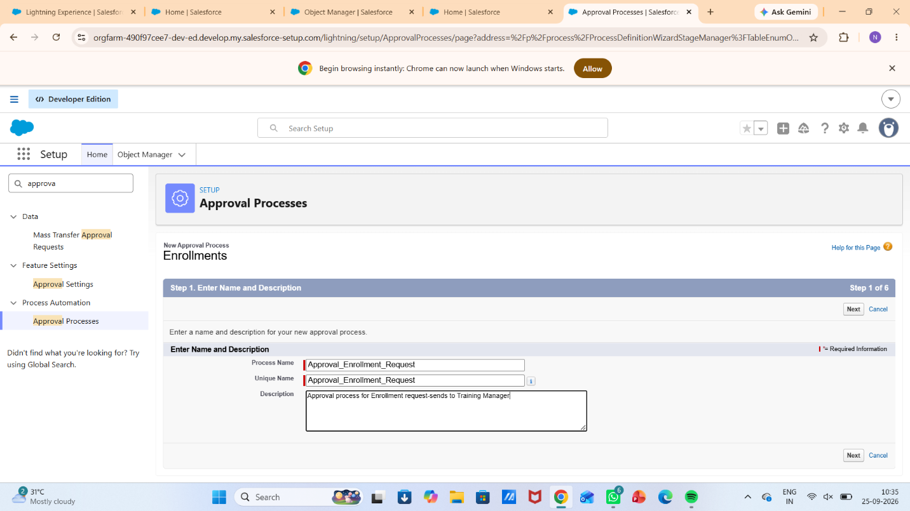

- Add Approval Step:
- Approver: specific Training Manager user.
- 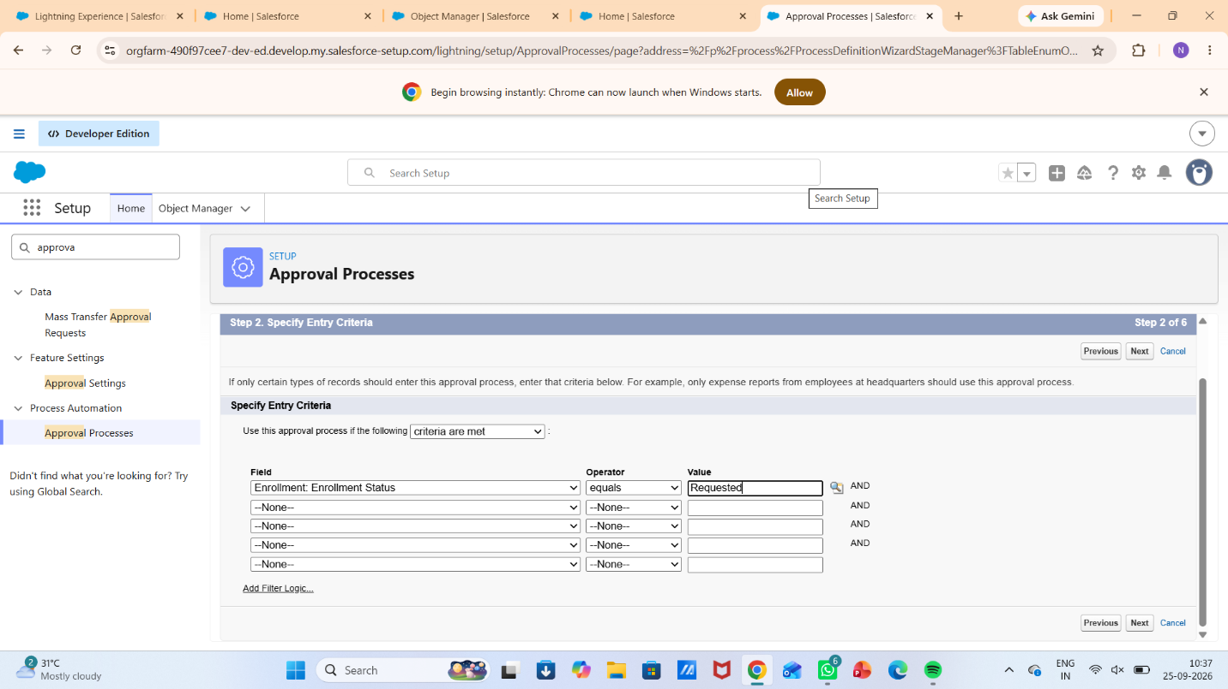

- Under Final Approval Actions:
- Add Field Update to set Enrollment_Status__c = "Approved".

- Under Final Rejection Actions:
- Add Field Update to set Enrollment_Status__c = "Rejected".
- 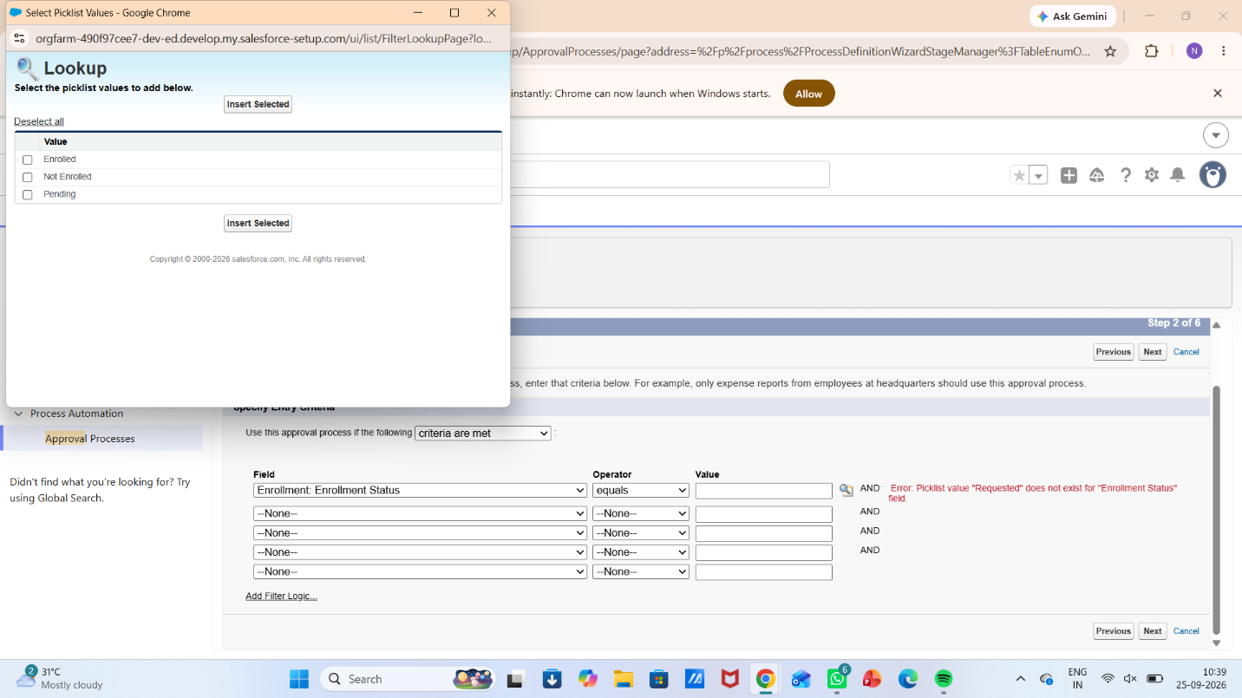

- Add Email Alert to send rejection email to student.

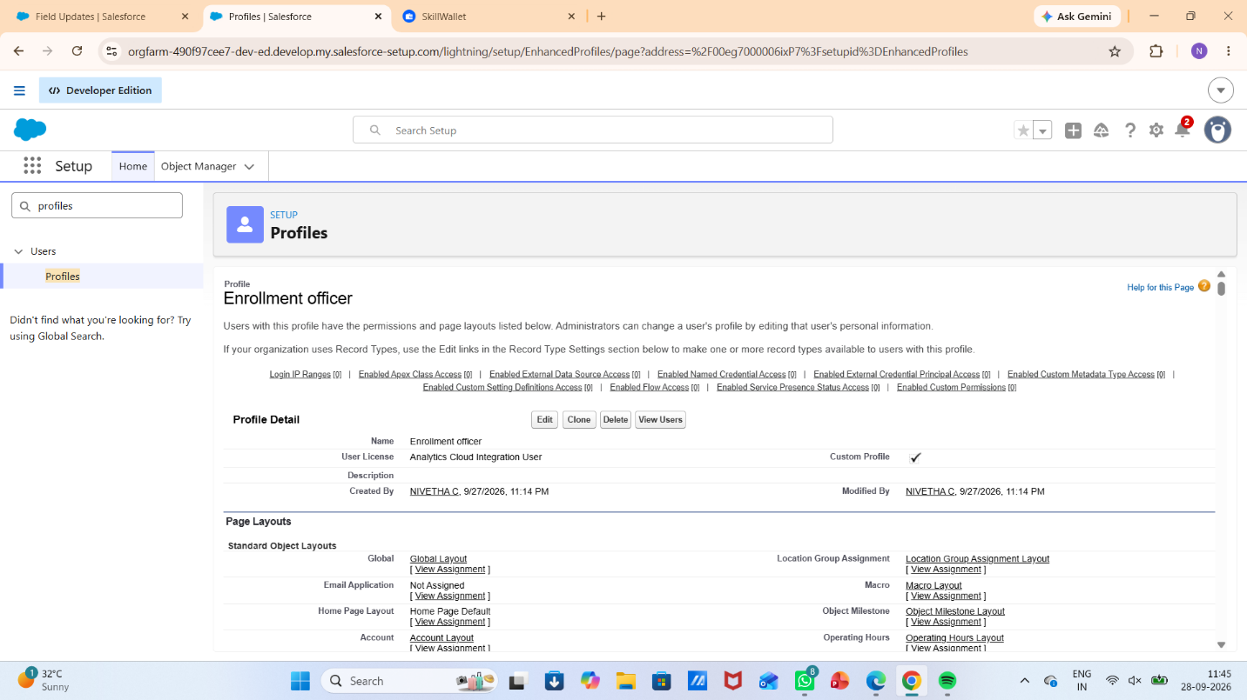

- Activate the approval process.

Milestone 7- Tabs

Activity 1: Creating a Tab for the Student Object:
Go to Setup.
- In the Quick Find box, type Tabs.
- Under Custom Object Tabs, click New.
- Select Student from the object list.
- Choose a tab style (icon).
- Click Next, assign it to all profiles, and then click Save.

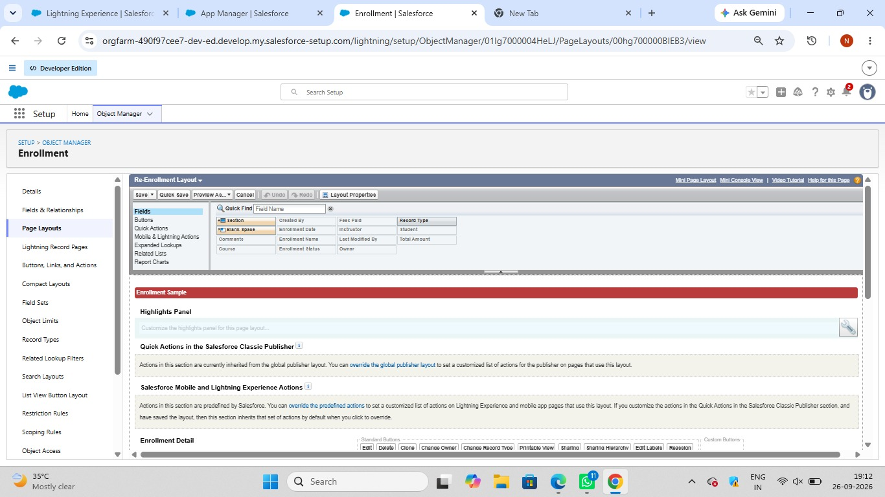

Activity 2: Creating Remaining Tabs

Now create the Tabs for the remaining Objects, they are “Courses, Instructors, Enrollment”.
Follow the same steps as mentioned in Activity -1

Milestone 8 - The Lightning App

Activity 1: Creating the Lightning Application for the Project
Navigate to Setup.

Enter App Manager in the Quick Find search box.
Click New Lightning App.
Provide the app details:
App Name: Student Enrollment & Course Management
Developer Name auto-fills
Description: Optional, but can describe the purpose of the app
Click Next and choose the following settings:
App Branding (optional): Add logo or select color theme
Navigation Style: Choose Standard Navigation
Click Next and assign the app to specific profiles (e.g., Admin, Enrollment Officer, Instructor).
Click Next to select the items (tabs) to be included in the app. Add:
- Student
- Course
- Instructor
- Enrollment
- Reports
- Dashboards
- Home
- Tasks
Click Next and review the app settings.
Finally, click Save & Finish.

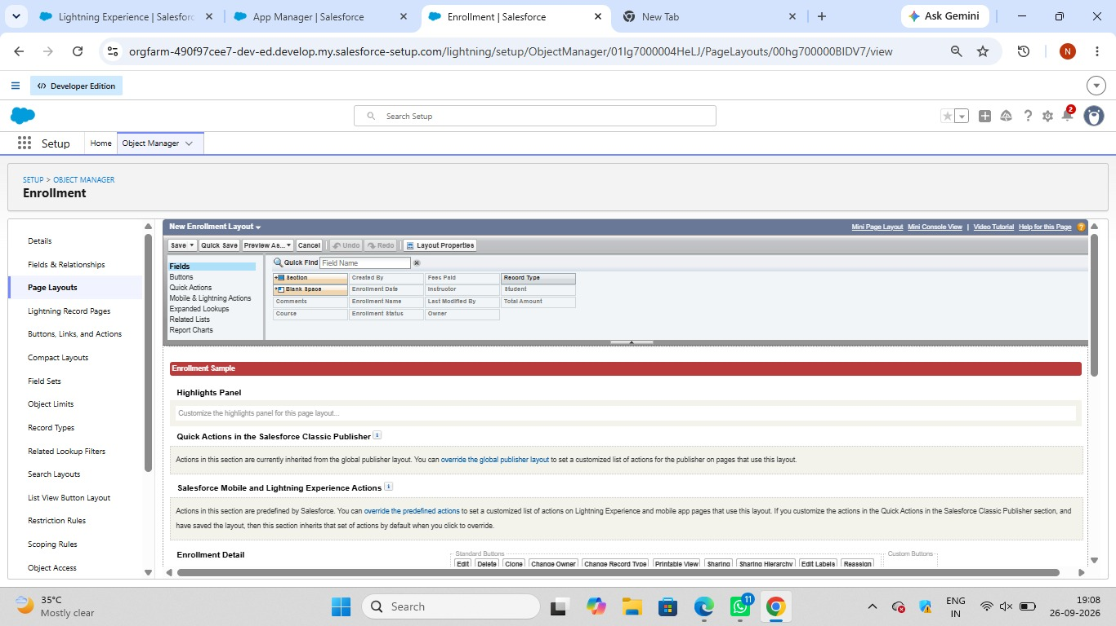

Milestone 9 – Page Layouts and Record:

Activity 1: Create Record Types for Enrollment:

Purpose:
To separate New Enrollment vs Re-Enrollment processes.
Steps:
1.Go to Setup → Object Manager → Enrollment__c.
2.Click Record Types → New.
3.For the first record type:
- Existing Record Type: Master
- Record Type Label: New Enrollment
- Enable for required profiles (Admin, Enrollment Officer).
- Select the default Page Layout → Save & New.
4.For the second record type:
- Record Type Label: Re-Enrollment
- Enable for the same profiles.
- Select the default Page Layout → Save.
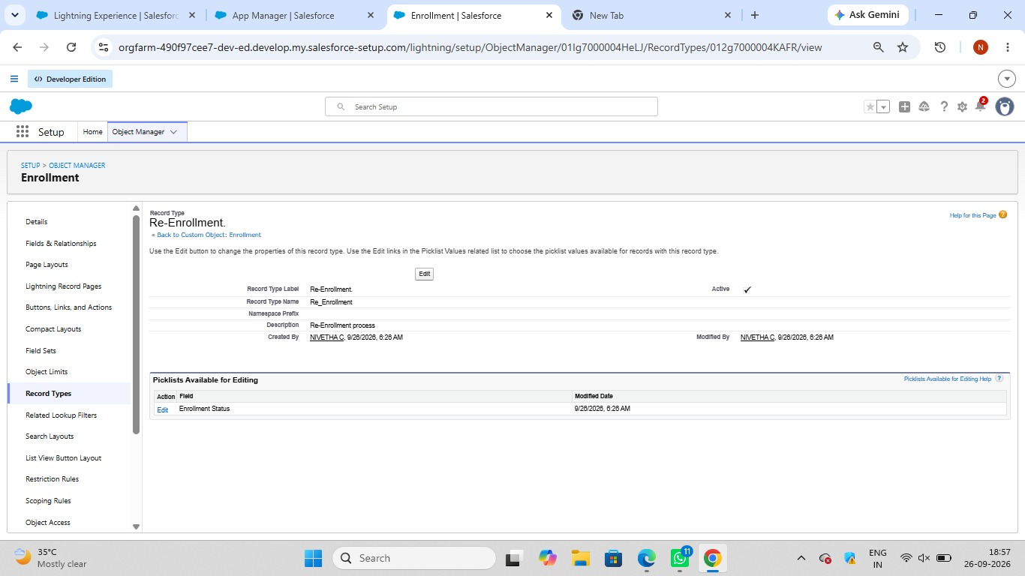

Activity 2: Separate Page Layout Creators for Each Enrollment Record Type

Purpose:
To show different fields for New Enrollment vs Re-Enrollment.

Steps:

1.Enrollment__c object → click Page Layouts.
2.Click New to create a layout for New Enrollment:
- Clone from existing Enrollment Layout → name it New Enrollment Layout → Save.
- Keep fields relevant for first-time enrollment: Student, Course, Instructor, Enrollment Date, Status, Fees, etc.
- Remove unnecessary re-enrollment fields if any.
- Click Save.

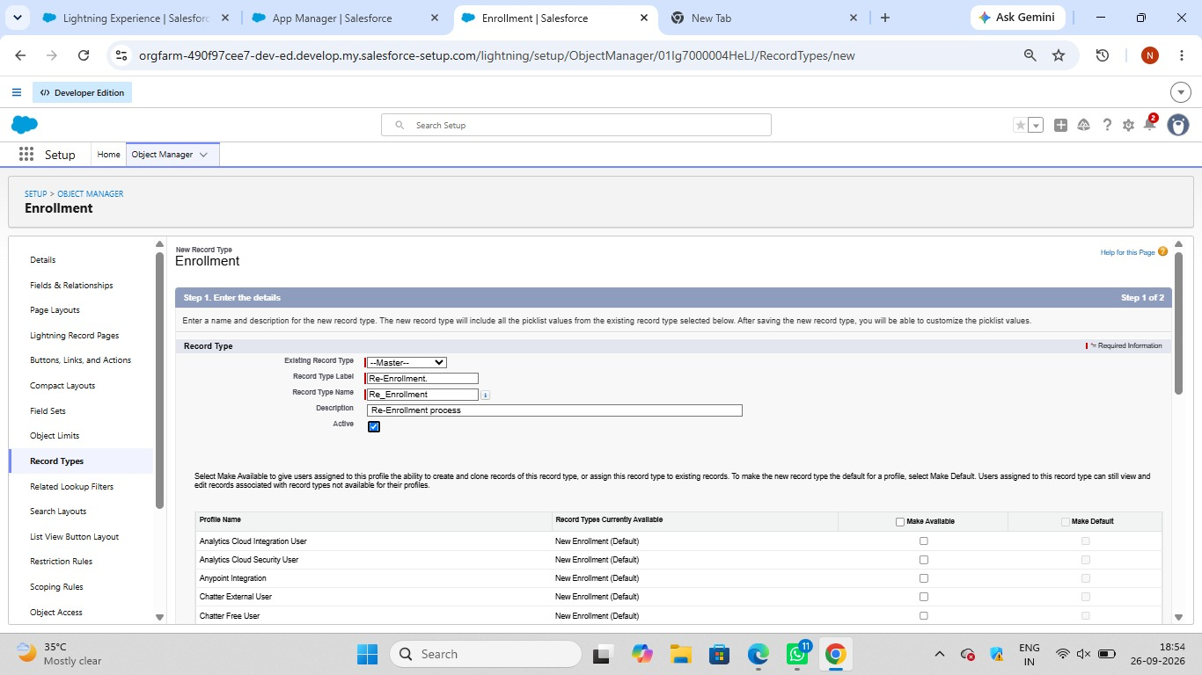
3.Again, click New to create Re-Enrollment Layout:
- Clone existing layout → name it Re-Enrollment Layout → Save.
- Include fields like previous Enrollment reference (if any), Re-Enrollment Reason, Status, Fees, etc.
- Click Save.

4.Click Page Layout Assignment → Edit Assignment.
5.For each profile and record type:

- New Enrollment → use New Enrollment Layout.
6.Re-Enrollment → use Re-Enrollment Layout.
Click Save.

Activity 3: Enrollment R Addelated Lists to Parent Objects:

Purpose:
To see all Enrollments from Student, Course, and Instructor records.
a) Student → Enrollment Related List
Go to Setup → Object Manager → Student__c.
Click Page Layouts → open the main layout.
In the palette, select Related Lists.
Drag Enrollments related list onto the layout.
Customize columns if needed → Save.
b) Course → Enrollment Related List
Go to Object Manager → Course__c → Page Layouts.
Open layout → add Enrollments related list.
Save.
c) Instructor → Enrollment Related List
Go to Object Manager → Instructor__c → Page Layouts.
Open layout → add Enrollments related list.
Save.

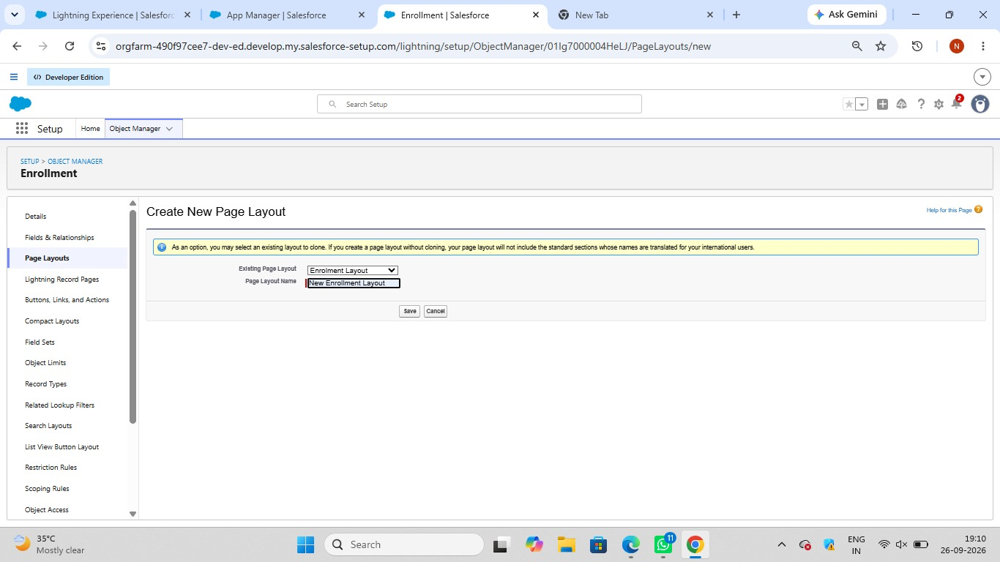

Milestone 10 – Automation with Flow

Activity 1: Auto-Populate Enrollment Date (Record-Triggered Flow)

Purpose:
Set Enrollment_Date__c to today when Enrollment is created.

Steps:

- Go to Setup → Flows → New Flow.
- Select Record-Triggered Flow → Create.
- Object: Enrollment__c.
- Trigger: A record is created.
- Optimize for Actions and Related Records → Done.

- Add Update Records element:
- Label: Set Enrollment Date.
- Use a record that triggered the flow.
- Field: Enrollment_Date__c → Value: $Flow.CurrentDate.
7.Save as SetEnrollmentDate → Activate.

Activity 2: Send Email When Enrollment Approved

Purpose:
When Enrollment_Status__c = Approved, send email, alert admin, and set Student to Active.
Steps (high level for document):

- Create Email Template and Email Alert for student notification.

- Go to Flows → New → Record-Triggered Flow.
- Object: Enrollment__c, Trigger on update.
- Condition: Enrollment_Status__c Equals "Approved".

- Add Get Records to fetch related Student__c.

- Add Action (Email Alert) to send email to student.

- Add Action to notify Admin if needed.
- Add Update Records to set Student__c.Status__c = "Active".

- Save as Enrollment Approved Action → Activate.

Activity 3: Auto-Assign Instructor Based on Course Category

Purpose:
Assign Instructor automatically based on Course category.

Rules:

Technical → Instructor A
Language → Instructor B
Non-Technical → Instructor C

Steps:

- Prepare Instructor__c records with codes (e.g., INSTR_A, INSTR_B, INSTR_C).
- Create Record-Triggered Flow on Enrollment__c (created/updated).
- Add Get Records to fetch related Course__c.
- Add Decision element on Course__r.Category__c:
- Technical / Language / Non-Technical outcomes.
- For each outcome:
- Get Instructor record (A/B/C) based on code or name.
- Update Records: set Instructor__c = Get_Instructor_X.Id.
- Save as AutoAssign_Instructor → Activate.


Activity 4: Auto-Create Task for Follow-Up

Purpose:
When Enrollment is “Requested”, create a follow-up task for Admin.

Steps:

- Create Record-Triggered Flow on Enrollment__c.
- Trigger: Record created or updated; condition Enrollment_Status__c = "Requested".

- Add Get Records to fetch Admin user (by Username / Profile).
- Add Formula (Date): TODAY() + 2 for due date.

- Add Create Records for Task:
- Subject: Follow up on enrollment request.
- OwnerId: Admin user Id.
- WhatId: Enrollment Id.
- ActivityDate: formula Today + 2.

- Save as Create_Followup_Task → Activate.

Milestone 11 – Reports:

Activity 1: Create “Students by Status” Report

1.Go to Reports → New Report.
2.Report Type: Students.
3.Group rows by Status__c.
4.Add columns as needed (Name, Email, Phone).
5.Save as Students by Status.


Activity 2: Create “Enrollments by Course” Report

1.New Report → Report Type: Enrollments.
2.Grouprows by Course__r.Name.
3.Show Record Count per course.
4.Save as Enrollments by Course


Activity 3: Create “Pending Enrollment Approvals” Report

- New Report → Enrollments report type.
- Filter: Enrollment_Status__c = "Requested".
- Add columns (Student, Course, Owner, Created Date).
- Save as Pending Enrollment Approvals.



Activity 4: Create “Revenue Report (Fees Paid)” Report

1.New Report → Enrollments report type.
2.Filter: Fees_Paid__c = TRUE.
3.Group by Course__r.Name.
4.Summarize Course_Fee__c or similar fee field.
5.Save as Revenue Report – Fees Paid.

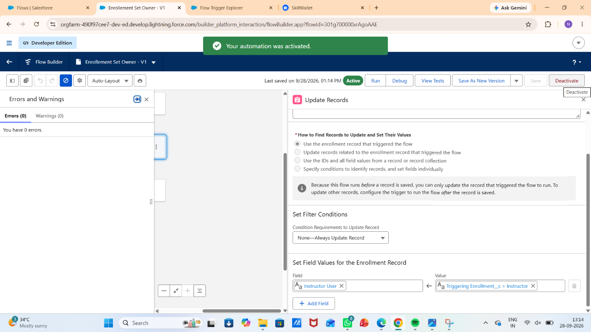


Milestone 12 – Dashboards:

Activity 1: Create “Student Managemet Dnashboard”

Steps:
- Go to Dashboards → New Dashboard.
- Name: Student Management Dashboard.
- 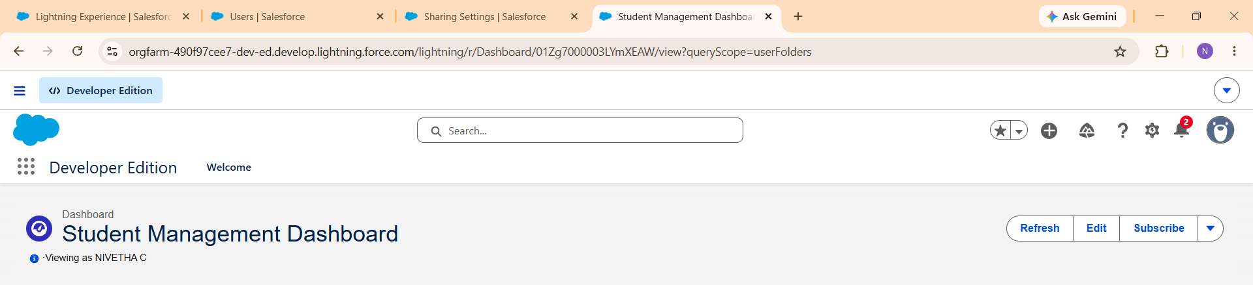

- Select folder → Create.
- Select the new Dashboard folder and Save.
Add components:
- Donut Chart → using Students by Status report.
- Bar Chart → using Enrollments by Course report.
- Gauge → using Revenue Report – Fees Paid (sum of revenue field).
- Table → using Pending Enrollment Approvals report.

- Arrange components on canvas.

Click Save → Done.

Milestone 13 – Security Setup

Activity 1: Configure Profiles
):
- Go to Setup → Profiles → New (or CloneProfiles Required:
- Admin – Full access.
- Enrollment Officer – Create/Update Enrollments.
- Instructor – Read-only access to assigned Enrollments.
- Steps (example for Enrollment Officer fName: Enrollment Officer.
- In Object Settings:
  - Enrollment__c: Read, Create, Edit.
  - Student__c / Course__c: Read (and Edit if required).
- Save.
Repeat similarly for Instructor profile with Read-Only on Enrollments

Activity 2: Create Permission Sets

- Go to Setup → Permission Sets → New.
- Create Custom Object Access (additional access to project objects if needed).
- Create Dashboard Editor (Create/Customize Reports & Dashboards permissions).
- Assign to relevant users.

Activity 3: Configure Sharing & OWD

Steps:
- Go to Setup → Sharing Settings.
- Set Organization-Wide Defaults:
  - Students (Student__c): Public Read/Write.
  - Courses (Course__c): Public Read/Write.
  - Enrollments (Enrollment__c): Private.
- Save.
For Instructor access to assigned Enrollments, optionally:
- Add a User lookup on Enrollment (Instructor User).
- Use a simple Record-Triggered Flow to set OwnerId = Instructor User so they can see only their own records.

7. FUNCTIONAL & PERFORMANCE TESTING

During the testing phase, screenshots were captured from the Salesforce user interface to verify the proper functioning of all implemented features of the Student Enrollment & Course Management System (SECMS). These include student, course, instructor, and enrollment record creation; validation rule checks for mandatory fields, eligibility, and enrollment constraints; verification of record type behavior for different course categories; flow execution for automated enrollment approvals and seat availability checks; and Apex trigger functionality to ensure automatic confirmation and record updates. Additionally, screenshots of generated reports and dashboards were documented to validate accurate data visualization, enrollment tracking, and performance monitoring. Submit the Screenshots while testing.

8. ADVANTAGES & DISADVANTAGES

Advantages
- Centralized data
- Automated workflows
- Real-time reporting

Disadvantages
- Salesforce dependency
- Requires initial configuration effort

9. Conclusion:

The Salesforce Student Enrollment & Course Management System successfully streamlines the entire student academic lifecycle—from student registration and course creation to enrollment management, instructor assignment, approvals, revenue tracking, and reporting. By leveraging Salesforce’s automation tools such as validation rules, flows, approval processes, and dashboards, the system improves data accuracy, operational efficiency, and decision-making. This project demonstrates how Salesforce can transform manual academic processes into a scalable, reliable, and user-friendly digital solution.

10. FUTURE SCOPE
- Payment gateway integration
- Student self-service portal
- Analytics-driven insights
- Mobile access support

11. APPENDIX
- Source Code: Salesforce Configuration
- Dataset: Salesforce Objects
- GitHub / Demo: Salesforce Developer Org

Thank You

